# IOT ASSIGNMENT – 1

**Circuit Connection:**

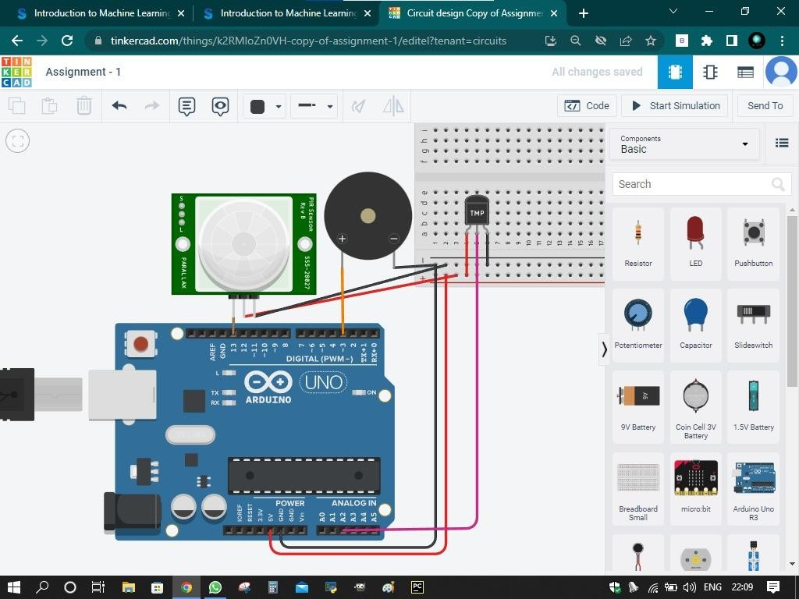

# CODE:

void setup()

{

Serial.begin(9600); pinMode(3,OUTPUT); pinMode(13,INPUT);

}

void loop()

{

{

double data=analogRead(A2); double n=data/1024;

double volt=n*5; double off=volt-0.5;

double temperature=off*100; Serial.print("Temperature data: "); Serial.println(temperature);

if (temperature <= 60)

{

digitalWrite(3,LOW);

}

else

{

digitalWrite(3,HIGH);

}

}

{

int motion=digitalRead(13); if (motion==1){

Serial.println("Motion is Detected "); digitalWrite(3,HIGH);

delay(10000);

}

else{

Serial.println("No Motion"); digitalWrite(3,LOW);

}

}

}